**PIZZA Sales SQL Queries**

**A.KPI’s**

**1.Total Revenue:**SELECT SUM(total_price) AS Total_Revenue from pizza_sales

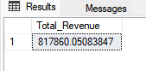

**2.Average Order Value:**

SELECT SUM(total_price) / COUNT(DISTINCT order_id)as Avg_Order_Value from pizza_sales

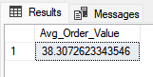

**3.Total Pizza Sold:**

SELECT SUM(quantity) as Total_Pizza_Sold from pizza_sales  
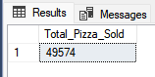

**4.Total Orders:**

SELECT COUNT(DISTINCT order_id) AS Total_Orders from pizza_sales

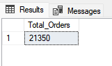

**5.Avg Pizzas Per Order:**

SELECT CAST(CAST(SUM(quantity) AS Decimal(10,2)) /

CAST(COUNT(DISTINCt order_id)AS Decimal(10,2)) AS Decimal(10,2)) As Avg_Pizzas_per_Order from pizza_sales

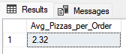

**B. Charts Requirment**

**1. Total Trend for total orders:**

SELECT DATENAME(DW, order_date) as order_day, COUNT(DISTINCT order_id) as Total_Orders

from pizza_sales

GROUP BY DATENAME(DW, order_date)

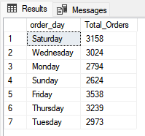

**2.Monthly Trends for Orders:**

SELECT DATENAME(MONTH, order_date) AS Month_Name, COUNT(DISTINCT order_id) AS Total_Orders

from pizza_sales

GROUP By DATENAME(MONTH, order_date)

ORDER BY Total_Orders DESC

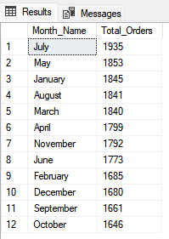

**3. Percentage of Sales by Pizza Category:**

SELECT pizza_category, sum(total_price) as Total_Sales, sum(total_price) * 100 /

(SELECT sum(total_price) from pizza_sales WHERE MONTH(order_date) = 1) AS PCT_Total_Sales

from pizza_sales

WHERE MONTH(order_date) = 1

GROUP BY pizza_category

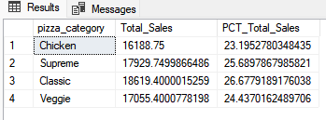

**4.Percentage of Sales By Pizza Size:**

SELECT pizza_size,CAST(sum(total_price)as Decimal(10,2)) as Total_Sales, CAST(sum(total_price) * 100 /

(SELECT sum(total_price) from pizza_sales Where Datepart(QUARTER,order_date) = 1) AS Decimal(10,2)) AS PCT

from pizza_sales

Where Datepart(QUARTER,order_date) = 1

GROUP BY pizza_size

Order By PCT DESC

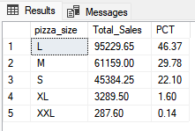

**5. Total Pizzas Sold by Category:**

SELECT pizza_category, SUM(quantity) as Total_Quantity_Sold

FROM pizza_sales

WHERE MONTH(order_date) = 2

GROUP BY pizza_category

ORDER BY Total_Quantity_Sold DESC

**6. Top 5 Pizzas by Revenue:**

SELECT Top 5 pizza_name, sum(total_price) as Total_Revenue from pizza_sales

GROUP BY pizza_name

Order By Total_Revenue DESC

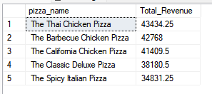

**7. Bottom 5 Pizzas by Revenue:**

SELECT Top 5 pizza_name, SUM(total_price) AS Total_Revenue

FROM pizza_sales

GROUP BY pizza_name

ORDER BY Total_Revenue

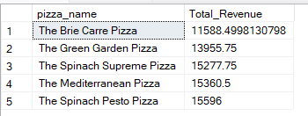

**9. Top 5 Pizzas by Quantity**

SELECT Top 5 pizza_name, SUM(quantity) AS Total_Pizza_Sold

FROM pizza_sales

GROUP BY pizza_name

ORDER BY Total_Pizza_Sold DESC

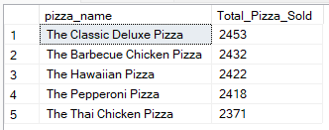

**10. Bottom 5 Pizzas by Quantity**

SELECT TOP 5 pizza_name, SUM(quantity) AS Total_Pizza_Sold

FROM pizza_sales

GROUP BY pizza_name

ORDER BY Total_Pizza_Sold

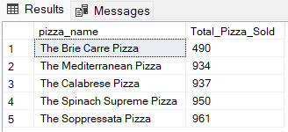

**11. Top 5 Pizzas by Total Orders**

SELECT Top 5 pizza_name, COUNT(DISTINCT order_id) AS Total_Orders

FROM pizza_sales

GROUP BY pizza_name

ORDER BY Total_Orders DESC

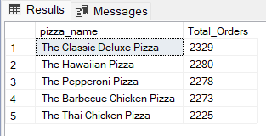

**12. Borrom 5 Pizzas by Total Orders**

SELECT Top 5 pizza_name, COUNT(DISTINCT order_id) AS Total_Orders

FROM pizza_sales

GROUP BY pizza_name

ORDER BY Total_Orders

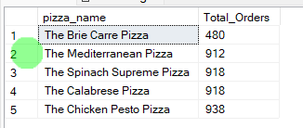

***NOTE***

If you want to apply the pizza_category or pizza_size filters to the above queries you can use WHERE clause. Follow some of below examples

SELECT Top 5 pizza_name, COUNT(DISTINCT order_id) AS Total_Orders

FROM pizza_sales

WHERE pizza_category = 'Classic'

GROUP BY pizza_name

ORDER BY Total_Orders ASC